Analysing the Presence of Heavy Metals in the Environment using Atomic Absorption Spectroscopy
By Cynthia van der Wielen

INTRODUCTION




Atomic absorption spectroscopy is used for analysing a large range of things that are important to know in our daily lives. In this text, analysing the presence of heavy metals in the environment using atomic absorption spectroscopy (AAS) will be explored. A heavy metal is classified as any metal or metalloid that can be of environmental concern (Wikipedia, 2015). Atomic absorption spectroscopy is a technique that involves the use of absorption of light by electrons in an atom to measure how much of an element is present in a sample of a substance, and in the case of heavy metals, the amount present in the environment (Smith, Davis, Disney, Hayes & Whan, 2015). Determining the presence of heavy metals is very important as these metals can cause enormous harm to all plants, animals and humans, as well as the environment is has been found in excessive amounts in.

ATOMIC ABSORPTION SPECTROSCOPY




Atomic absorption spectroscopy, a related technique to emission spectroscopy, is used to perform quantitative analysis of elements. AAS uses the principle of emission spectroscopy, which involves electrons of an atom, being excited by radiation and moving to higher energy levels, thereby absorbing the energy, and will absorb a particular amount of energy, characteristic for that particular element, allowing for the atom to be identified as each element absorbs a different amount of energy due to its electron configurations (Smith et al., 2015). An atomic absorption spectrometer is used for this process. The first step is to determine the element being analysed, as it is important to separate it from the other elements that will be present in a substance as if it were not separated, all the elements would then absorb the light. The sample of the element is first vaporised, changing the substance into atoms, then light is pulsed from a lamp made of the element being tested for, the sample will absorb the light, as it will have the same energy levels as the atoms emitted from the lamp. The light passes through the sample and is focused through a slit before entering a monochromator. (See Figure 1) The monochromator selects one wavelength of the light for analysis by the detector, which then measures the intensity of the light, and then displayed as a number, a measure of the amount of light that passed through the sample without being absorbed, this is the absorbance value. In this way, the amount of energy the sample absorbed can be found out. (Smith, Davis, Disney, Hayes & Whan, 2015)
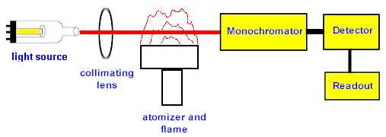




Figure 1: Simplified diagram of the process of atomic absorption spectroscopy. Source: (Chemtech.org, 2015)

CALLIBRATION CURVES




The data that is collected by atomic absorption spectroscopy can be represented and further analysed on a calibration curve. This is where the absorbance value and amount of the element sample is compared to known samples. The first step is to prepare a number of known concentrations of the element, with their intensities measured by atomic absorption spectroscopy. A calibration curve of concentration against absorbance value is plotted (see Figure 2). By using the calibration curve, the concentration of samples can be compared with samples that have not yet been determined by comparing its absorbance value. (Smith, Davis, Disney, Hayes & Whan, 2015)
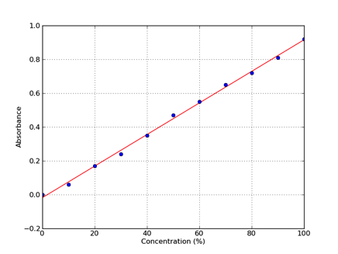




Figure 2: An example of a calibration curve. Source: (Iorodeo.com, 2012)

IMPORTANCE OF ANALYSING HEAVY METALS USING AAS
Analysing the presence of heavy metals in the environment is very important for a number of reasons. Heavy metals are a major environmental concern due to their pervasiveness and persistence in the environment and in organisms. Heavy metals are naturally found in the earth, but become concentrated due to human caused activities, commonly from mining and industrial wastes, vehicle emissions, lead-acid batteries, fertilisers, paints and treated woods coming into contact with the environment and organisms (Wikipedia, 2005). Heavy metals need to be analysed due to the harm that it can cause to human, plant, animal and environmental health. Plants, animals and humans can take in heavy metals via air inhalation, diet and manual handling, causing irreversible damage when it accumulates in the body, which can occur, as they are hard to metabolise (Wikipedia, 2015). Heavy metals when found concentrated in water source due to leaching is catastrophic as moving water quickly transports the chemicals to many locations, spreading the pollution further, as well as wreaking havoc in drinking water supplies. Common heavy metals are chromium, cobalt, nickel, copper, zinc, arsenic, selenium, silver, cadmium, mercury, thallium, and antimony as well as lead, with lead being the most common heavy metal found in high concentration (Srikanth, Somasekhar, Kanthi & Raghu Baru, 2013). Heavy metal contamination has caused death in humans and animals, corrosion, poisoning, cancers and destruction of the environment, providing many reasons why determining the presence and concentration of heavy metals is imperative. (See Figure 3)
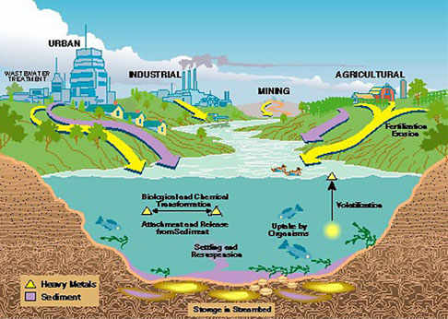

Figure 3: Heavy metal reservoirs in the environment. Source: (TreeHugger, 2015)

ANALYSING HEAVY METALS USING AAS









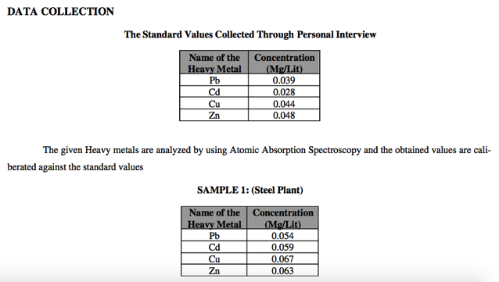
Heavy metals can be analysed and detected in the environment using AAS typically by making use of a flame to atomise the sample, which involves three steps in turning a liquid sample into an atomic gas. The liquid solvent is evaporated so that the dry sample remains, which is then vaporised into a gas, and lastly, the compounds that make up the sample, are broken up into free atoms. If heavy metals were being tested in soil, the soil would need to be dissolved in liquid, unnecessary if heavy metal presence was being tested in water. This is because AAS only works with liquids as the substances are vaporised in the process of atomising the element. (Garcia & Baez, 2012) The calibration curve is then used to measure how much of a given heavy metal is present in a sample. To generate this curve, a specific wavelength is selected, and the detector is set to measure only the energy transmitted at that wavelength. As the concentration of the atom in the sample increases, the absorption will also increase. A series of samples containing known concentrations of the compound of interest are analysed, and the corresponding absorbance, which is the opposite percentage of light transmitted, is recorded. The measured absorption at each concentration is then plotted, so that a straight line can then be drawn between the resulting points. From this line, the concentration of the substance under investigation is deduced from the substance’s absorbance. In this way, comparing them to known elements helps identify the heavy metals that are present and in what concentration. Figure 4 shows the collected data after testing a steel plant in Visakhapatnam, India using AAS, showing that there was a significant amount more heavy metal detection than the accepted allowance of heavy metal presence.

Figure 4: Analysis of heavy metal presence in an area in India compared with accepted amounts. Source: (Chemtech.org, 2015)

CONCLUSION




With the use of atomic absorption spectroscopy, concentrations of potentially harmful chemicals can be detected, particularly the presence of heavy metals in the environment, preventing harm from happening on a more widespread scale. AAS uses the process of absorption spectroscopy in order to work out the amount of energy a certain element absorbs, which helps identify the amount of an element is present, represented on a calibration curve. Electron configurations of elements determine the quantity of energy absorbed, unique to each element, thereby helping us to identify each substance. Without analysing the presence of heavy metals in the environment extensive damage could occur in many aspects of life, as was seen earlier in our history. With the development of AAS, extensive damage is becoming more preventable thanks to the advanced technology we now have.

REFERENCES
Chemtech.org, (2015). CHT 212 - atomic absorption. Retrieved 21 March 2015, from http://chemtech.org/cn/ctec2431/2431-7.htm
Garcia, R., & Baez, A. (2012). Atomic Absorption Spectrometry (AAS) (1st ed.). Ciudad Universitaria, Mexico City: InTech. Retrieved from http://cdn.intechopen.com/pdfs-wm/26275.pdf
Iorodeo.com,. (2012). Calibration curve | IO Rodeo Inc.. Retrieved 21 March 2015, from http://www.iorodeo.com/content/calibration-curve
Smith, D., Davis, A., Disney, A., Hayes, V., & Whan, R. (2015). Nelson Chemistry Units 1 & 2 For the Australian Curriculum (pp. 127-130). Melbourne, Victoria: Cengage Learning.

Srikanth, P., Somasekhar, A., Kanthi, G., & Raghu Babu, K. (2013). Analysis of Heavy Metals by Using Atomic Absorption Spectro-scopy from the Samples taken around Visakhapatnam. International Journal Of Environmental Ecology, Family And Urban Studies (IJEEFUS), 3(1), 127-132. Retrieved from http://www.tjprc.org/download.php?fname...13.Analysis%20of%20.full.pdf

TreeHugger, (2015). Organic Agriculture Wrongly Accused As Prominent Cause Of Heavy Metal Accumulation In Soil. Retrieved 21 March 2015, from http://www.treehugger.com/green-food/organic-agriculture-wrongly-accused-as-prominent-cause-of-heavy-metal-accumulation-in-soil.html


Wikipedia,. (2015). Heavy metal (chemistry). Retrieved 21 March 2015, from http://en.wikipedia.org/wiki/Heavy_metal_(chemistry)

REFERENCES

Chemical Technology. Introduction to atomic absorption spectrophotometry. Retrieved 21 March 2015, from http://chemtech.org/cn/ctec2431/2431-7.htm

García, R., & Báez, A. (2012). Atomic absorption spectrometry (AAS). In M. Farrukh, Atomic Absorption Spectroscopy (1st ed., pp. 1-12). InTech. Retrieved from http://cdn.intechopen.com/pdfs-wm/26275.pdf

IORodeo (2012). Calibration curve. Retrieved 21 March 2015, from http://www.iorodeo.com/content/calibration-curve

Nield, J. (2008). Organic agriculture wrongly accused as prominent cause of heavy metal accumulation in soil. Retrieved 21 March 2015, from http://www.treehugger.com/green-food/organic-agriculture-wrongly-accused-as-prominent-cause-of-heavy-metal-accumulation-in-soil.html

Smith, D., Davis, A., Disney, A., Hayes, V., & Whan, R. (2014). Nelson Chemistry Units 1 & 2 for the Australian Curriculum (pp. 127-130). Melbourne, Victoria: Cengage Learning.

Srikanth, P., Somasekhar, A., Kanthi, G., & Raghu Babu, K. (2013). Analysis of heavy metals by using atomic absorption spectro-scopy from the samples taken around Visakhapatnam. International Journal Of Environmental Ecology, Family And Urban Studies (IJEEFUS), 3(1), 127-132. Retrieved from http://www.tjprc.org/download.php?fname...13.Analysis%20of%20.full.pdf

Wikipedia (2015). Heavy metal (chemistry). Retrieved 21 March 2015, from http://en.wikipedia.org/wiki/Heavy_metal_(chemistry)

CONTENT
Aspect | 0 marks | 2 marks | 4 marks | 6 marks
How the instrument works | Describes a general principle of how machine works but lacks many details | A diagram shows the parts of the instrument and some information is given about what the different parts of the instrument do. | A diagram shows the function of the machine and information is given about the role of different parts of the instrument. Some description of chemical principles underpinning how the machine works using appropriate terminology (e.g. emission and absorption for AAS, elution and retention for GC-MS) | The function of each part is clearly described with details that show a level of research (i.e. not just paraphrased from textbook). Gives elaborate background into the chemical principles relevant to the analytical method (e.g. energy levels and absorption spectra for AAS, chromatographic principles for GC, etc.)
How data from the instrument is used | No explanation of how the output from the machine is used | Describes the type of output generated by the instrument. | Describes how the output of the instrument can be used to analyse, identify or detect substances and includes an appropriate image/table. | Explains how the results are used to analyse, identify or detect substances. Includes example AAS data or GC-MS data and demonstrates how this would be used for the particular application described.
Description of application | Lists the chosen application | Explains the importance of the chosen application. | Explains the importance of the chosen application and describes the chemistry of the substances which need to be analysed.

COMMUNICATING THROUGH ACADEMIC WRITING:
Aspect | 0 marks | 1 mark | 2 marks
References list | - | Most references are correctly formatted using APA. Occasional minor problems. | All references correctly formatted using APA. No errors in referencing details.
In-text citations | - | Some attempt to use in-text citations but some parts are missing citations. | All information that is not common knowledge is attributed using a form of in-text citations.  PART 2: ASSIGNMENT  Content = 16 / 16  Communication = 6.5 / 8  Total = 22.5 / 24  Overall comments:  Great report. Information was there and was largely correct (except for the need to separate elements prior to analysis)  Your writing is good but you need to proofread your work and edit to make information more concise.
Sources | - | At least three sources are used including at least one text source.
Conventions for figures and tables | - | Includes at least one figure or table. All figures and tables are labelled, include captions and sources, and are referenced in the main text.
Headings | - | Divides report into logical sections using headings.
Writing | - | High quality presentation of writing with minimal spelling or grammar errors

